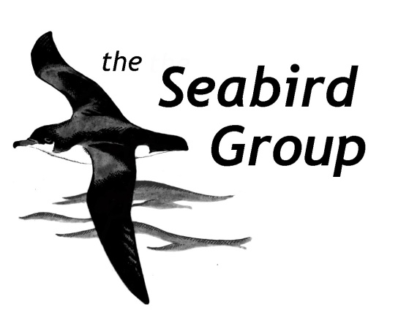

GRANT APPLICATION FORM

Please ensure that the fullest possible information is provided to enable a complete assessment to be made of the proposed project.

- Name of Applicant and/or Organisation:

- Address:

- Telephone number:

- E-mail address:

- Title and study area of project:

- Description of Project (Max 800 words): (Include ALL of the following sections: background information, specific aims, details of methodology, likely timescale, animal welfare considerations. Provide additional information, past reports, examples of data on a separate sheet or attached file).

- Total cost of project (please include a rough breakdown of costs: travel, subsistence, equipment etc):

- Amount of grant requested:

- What the grant will be used for:

- How are remaining costs being met (other grants, own contributions etc)? For other grants please give details (organisation, amount, year):

- Are you a Seabird Group member:

- Are you a student (if so, please detail):

- Declaration:
I/We certify that all the information given on this form is to the best of my/our knowledge correct and I/We agree to abide by any requirements or conditions attached to any award of the grant by the Seabird Group.

Signature of Applicant (s):
Position (if applicable):
Date:

Please list any enclosures/ attachments:

Please e-mail this form (plus any attachments) to the Secretary: secretary@seabirdgroup.org.uk

For official use only:
Date received:
Date circulated to committee:
Decision:

Amount awarded:

Date applicant informed of result of application:
Date summary report received:

